

VEHICLE RENTAL

SYSTEM AT HOTEL

LECTURE NAME : SIR LEZAM BIN MOHD LEHAT

GROUP MEMBERS :-

* MUHAMMAD AKMAL HAKIM BIN MOHD NOR
* MUHAMMAD HAMIZAN BIN MOHD ZIN
* MUHAMMAD AMSYAR BIN OMAR

CONTENTS:

|  |  |  |
| --- | --- | --- |
| NO | CONTENTS | PAGE |
| 1 | CONTENTS | 2 |
| 2 | PROJECT BACKGROUND | 3 |
| 3 | OBJECTIVE & PROJECT SCOPE | 4 |
| 4 | IMPLEMENTATION:-   * SELECTION * TYPE OF CAR * CITIZENSHIP * REPETITION   - COUNTER LOOP  - SENTINEL LOOP   * FUNCTION * FUNCTION NOT RETURN VALUE WITHOUT PARAMETER * FUNCTION WITH PARAMETER (PASSING) * FUNCTION NOT RETURN VALUE WITH PARAMETER * FUNCTION RETURN VALUE WITH PARAMETER PASSING | 5  6-8  9-12 |
| 5 | PROGRAM TESTING | 13-15 |
| 6 | CONCLUSION | 16 |
| 7 | DISK | 17 |

PROJECT BACKGROUND

Nowadays, with the increase in the number of tourist visiting Malaysia, they demand for an easier vehicle renting system at a hotel. They need a proper and systematic way to easily rent a car at their hotel. Our project is to create a system for the user to rent a variety vehicle that is easy for them to book .The system also ask the user to register if they want to rent another car and will display Total Profit.

|  |  |  |
| --- | --- | --- |
| **Vehicle Category** | **Vehicle type** | **Price** |
| PERSONAL | 1. WAJA 2. WIRA | 1. RM50 2. RM40 |
| FAMILY | 1. Exora 2. ALPHARD | 1. RM120 2. RM140 |
| LUXURY | 1. BMW 2. MERCEDES | 1. RM200 2. RM300 |
| SCOOTER | 1. HONDA 2. MODENAS | 1. RM30 2. RM40 |
| SUPERBIKE | 1. DUCATTI 2. KAWASAKI | 1. RM200 2. RM150 |
| SCRAMBLER | 1. TRIUMPH 2. YAMAHA | 1. RM90 2. RM80 |
| **COST OF DRIVER RM 60** | | |

OBJECTIVE

* To help tourist rent a vehicle easier at Hotel .
* To create a much more modernize system that is helpful for the hotel employee at work.
* To create a simple program that is easy to understand and easy to handle by the tourist or its user.
* To modernize the way hotel around Malaysia to have a very good program for renting a car.

PROJECT SCOPE

* Covers the procedure to rent a vehicle from car to motorcycle.
* Covers the necessity if a person need a driver.
* Shows the total profit of the day .
* Covers the how many days if the someone wants to rent a vehicle.
* Provide discount for citizen .

LIST OF SELECTION:-

**TYPE OF VEHICLE SELECTION :-**

In this system we have created a lot of selection one of them is to choose what type of vehicle to rent which is car or motorcycle. In this selection we declare vehicle as the variable input (char vehicle[100];) . Here is the coding of this selection.

cout<<"\n\tPLEASE CHOOSE WHAT TYPE OF VEHICLE TO RENT :";

cout<<"\n\t[1] CAR\n\t[2] MOTORCYCLE\n\n\t -->";

cin>>vehicle;

**CITIZENSHIP SELECTION :-**

In this function , it have two option which is citizen or foreigner . The user have to enter if they are a citizen or not. If the user is a citizen they will get a 50% worth of discount from their total rent bill but not including driver price. Whereas the foreigner will have to pay the actual price. Here is the coding of this selection.

void citizen()

{

cout<<"\n\t PLEASE CHOOSE STATUS :";

cout<<"\n\t [1] CITIZEN";

cout<<"\n\t [2] FOREIGNER";

cout<<endl;

cout<<"\n\t -->";

cin>>citizenship;

if (strcmp(citizenship,"CITIZEN")==0)

{

discount=0.5;

}

else if (strcmp(citizenship,"FOREIGNER")==0)

{

discount=0;

}

}

LIST OF REPETITION:-

**USER INFORMATION COUNTER CONTROL LOOP:-**

In this loop, we ask the user how many person will be using the vehicle that they have decided. This is to ensure the safetyness of the user. Once the user have enter the number of person using the vehicle, it will ask the name , phone number and the id card until the counter stop. Here is the coding of this loop.

while (count<=manyperson)

{

cout<<"\n\t*********************************************** ***************";

cout << "\n\tEnter name :";

cin.ignore();

cin.getline(namebook,100);

cout << "\n\tEnter phone number :";

cin >> phonenumber;

cout << "\n\tENTER ID CARD :";

cin >> date;

count++;

}

**MAIN FUNCTION SENTINEL LOOP:-**

We have implemented a sentinel loop in the main function. Once the main function has executed all function, variables and etc. the program will ask the user if they want to rent another vehicle. If the user type ‘y’, than the program will execute again and again until the user type ‘N’ to stop. This is the example of our sentinel loop:

df

void main()

{

char countt;

do

{

intro();

vehicletype();

intro();

citizen();

intro();

info();

intro();

cout<<"\n\t Insert Number of days to rent:";

cin>>days;

intro();

vehicleoption();

intro();

carAndMotorType();

intro();

driveroption();

intro();

userinformation();

intro();

allreceipt();

cout<<"\n\tDo you want to continue?[Y-yes/N-no]";

cout<<"\n\t-->";

cin>> countt;

}while(countt=='Y'||countt=='y');

system("pause");

}

**CITIZENSHIP SENTINEL LOOP:-**

Whenever the user enter the wrong data , the function will loop again until the correct data received from the user. Here is the example :- SD

SD

void citizen()

{

bool error = false;

while(!error)

{

cout<<"\n\t PLEASE CHOOSE STATUS :";

cout<<"\n\t [1] CITIZEN";

cout<<"\n\t [2] FOREIGNER";

cout<<endl;

cout<<"\n\t -->";

cin>>citizenship;

if (strcmp(citizenship,"CITIZEN")==0)

{

error = true;

discount=0.5;

}

else if (strcmp(citizenship,"FOREIGNER")==0)

{

error = true;

discount=0;

}

else

cout << "\nError~~";

}

}

LIST OF FUNCTION:-

FUNCTION NOT RETURN VALUE WITHOUT PARAMETER:

void allreceipt()

{

totalprice=days*vehicleprice;

totaldriver=days*costdriver;

totaldiscount=totalprice*discount;

totalcostoverall=totalprice+totaldriver-totaldiscount;

totalprofit=totalprofit+totalcostoverall;

cout<<"\n\t _______________________________________________";

cout<<"\n\t YOUR RECEIPT ";

cout<<"\n\t NAME :"<<name;

cout<<"\n\t ID CARD :"<<idcard;

cout<<"\n\t LICENSE NUMBER :"<<license;

cout<<"\n\t STATUS :"<<citizenship2;

cout<<"\n\t TYPE OF VEHICLE :"<<vehicle1;

cout<<"\n\t CATEGORIES OF VEHICLE:"<<typecarandmotor1;

cout<<"\n\t VEHICLE BRAND :"<<vehiclename;

cout<<"\n\t NUMBER OF DAYS RENT :"<<days;

cout<<"\n\t NUMBER OF PERSON USE :"<<manyperson<<" PERSON";

cout<<"\n\t DRIVER OPTION :"<<driver2;

cout<< fixed << setprecision(2);

cout<<"\n\t RENT PRICE :RM"<<totalprice;

cout<<"\n\t DRIVER COST :RM"<<totaldriver;

cout<<"\n\t DISCOUNT :RM"<<totaldiscount;

cout<<"\n\t TOTAL PRICE :RM"<<totalcostoverall;

cout<<"\n\t _______________________________________________";

}

FUNCTION WITH PARAMETER PASSING (BY REFERENCE):

void citizen(int citizenship)

{

bool error = false;

while(!error)

{

if (citizenship='1')

{

strcpy_s(citizenship2,"CITIZEN");

error = true;

discount=0.5;

}

else if (citizenship='2')

{

strcpy_s(citizenship2,"FOREIGNER");

error = true;

discount=0;

}

else

{

cout<<"\nerror";

}

}

}

FUNCTION NOT RETURN VALUE WITH PARAMETER:

void userinformation(char* namebook,char* phonenumber,char* date)

{

int count=1;

cout << "\n\t*******YOUR INFORMATION IS RECORDED FOR SAFETY PURPOSE********";

cout << "\n\t**************************************************************";

cout << "\n\tENTER HOW MANY PERSON USES THIS VEHICLE:";

cout << "\n\t-->";

cin >> manyperson;

while (count<=manyperson)

{

cout << "\n\t**************************************************************";

cout << "\n\tEnter name :";

cin.ignore();

cin.getline(namebook,100);

cout << "\n\tEnter phone number :";

cin >> phonenumber;

cout << "\n\tENTER ID CARD :";

cin >> date;

count++;

}

}

FUNCTION RETURN VALUE WITH PARAMETER:=

double info(char* name,char idcard,char license)

{

cout<<"\n\t NAME :";

cin.ignore();

cin.getline(name,100);

cout<<"\n\t ID CARD:";

cin>>idcard;

cout<<"\n\t LICENSE NUMBER:";

cin>>license;

return 0;

}

PROGRAM TESTING :-

**DISPLAY SCREEN FOR USER INFORMATION:**

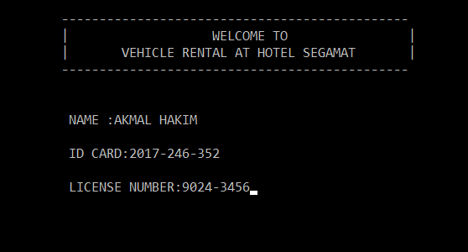

**DISPLAY SCREEN FOR CHOOSING TYPE OF CAR:**

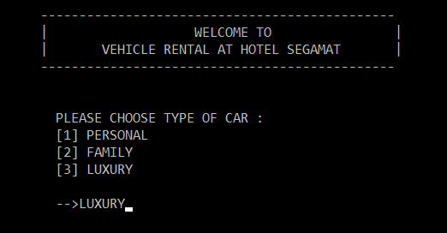

**DISPLAY SCREEN FOR THE RECEIPT PAYMENT:**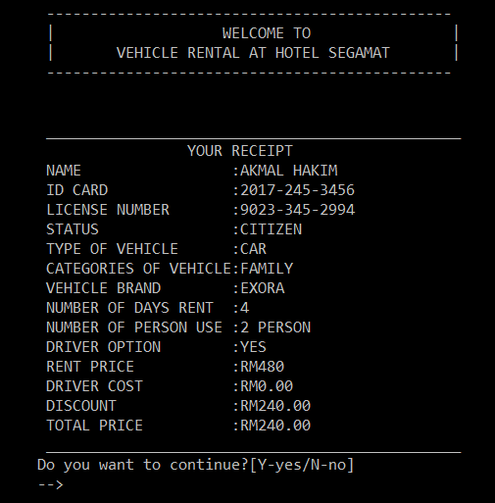

**DISPLAY SCREEN FOR THE SUMMARIZE OF THE PROGRAM:**

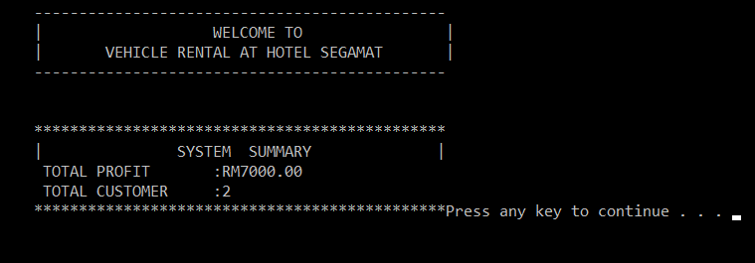

**CONCLUSION**

At the end of the days this system is not only covers the renting system but also include the total profit of the day. Thus, we wish that this program can make the way of renting a vehicle is much easier than the manual way. The manual way which is to queue in a long line waste up a lot of time therefore this system will make it faster. We would also like to thanks to our lecturer, Sir Lezam bin Lehat for giving us all the guide and help on establishing this alternative system. We now know how to implemented loop and function in visual c++ thus our project will look more organize and neat. In a nutshell, we hope that this system will be used to all hotel around Malaysia.